**WEEK – 5**

**MANDATORY HANDS-ON – Microservices with API gateway**

**Hands-on: Creating Microservices for account and loan**

**You will create two independent Spring Boot microservices:**

* **Account Microservice – listens on port 8080**
* **Loan Microservice – listens on port 8081**
  1. **Create the account microservice**

**STEP 1: Go to Spring Initializr**

Open your browser and go to: <https://start.spring.io>

**STEP 2: Fill Project Metadata**

* **Group:** com.cognizant
* **Artifact:** account

**STEP 3: Add Dependencies**

Click "Add Dependencies" and include:

* Spring Web
* Spring Boot DevTools

**STEP 4: Generate and Extract Project**

* Click **Generate**, it downloads a ZIP file.
* Extract the ZIP to a folder inside your **Eclipse Workspace**.

**STEP 5: Create package and Controller class**

* In src/main/java/com.cognizant.account, create:
  + **Package name:** com.cognizant.account.controller
  + **Class name:** AccountController

package com.cognizant.account.controller;

import org.springframework.web.bind.annotation.*;

*@RestController*

public class AccountController {

*@GetMapping*("/accounts/{number}")

public Account getAccount(*@PathVariable* String number) {

return new Account(number, "savings", 234343);

}

static class Account {

private String number;

private String type;

private double balance;

public Account(String number, String type, double balance) {

this.number = number;

this.type = type;

this.balance = balance;

}

public String getNumber() { return number; }

public String getType() { return type; }

public double getBalance() { return balance; }

}

}

**STEP 6: Run and Test**

* Right-click AccountApplication.java → Run As → Java Application
* Open browser: 👉 <http://localhost:8080/accounts/00987987973432>

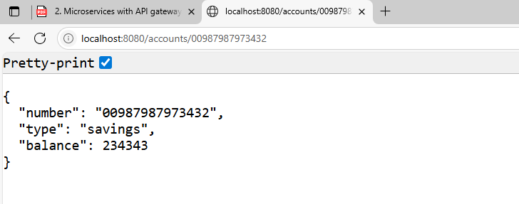

* 1. **Create the account microservice**

**STEP 1: Go to Spring Initializr**

Open your browser and go to: <https://start.spring.io>

**STEP 2: Fill Project Metadata**

* **Group:** com.cognizant
* **Artifact:** loan

**STEP 3: Add Dependencies**

Click "Add Dependencies" and include:

* Spring Web
* Spring Boot DevTools

**STEP 4: Generate and Extract Project**

* Click **Generate**, it downloads a ZIP file.
* Extract the ZIP to a folder inside your **Eclipse Workspace**.

**STEP 5: Change port in application.properties**

* In src/main/resources/application.properties, add:

server.port=8081

**STEP 6: CREATE PACKAGE AND CONTROLLER**

In src/main/java/com.cognizant.loan, create:

* Package: com.cognizant.loan.controller
* Class: LoanController

package com.cognizant.loan.controller;

import org.springframework.web.bind.annotation.*;

*@RestController*

public class LoanController {

*@GetMapping*("/loans/{number}")

public Loan getLoan(*@PathVariable* String number) {

return new Loan(number, "car", 400000, 3258, 18);

}

static class Loan {

private String number;

private String type;

private double loan;

private int emi;

private int tenure;

public Loan(String number, String type, double loan, int emi, int tenure) {

this.number = number;

this.type = type;

this.loan = loan;

this.emi = emi;

this.tenure = tenure;

}

public String getNumber() { return number; }

public String getType() { return type; }

public double getLoan() { return loan; }

public int getEmi() { return emi; }

public int getTenure() { return tenure; }

}

}

**STEP 7: RUN AND TEST**

* Right-click LoanApplication.java → Run As → Java Application
* Open browser:  
  👉 <http://localhost:8081/loans/H00987987972342>

